QUOTATION

Client Information
Al Zulfi hospital
Reference No. | RFQ#87293
Region | Riyadh
City | Al Zulfi
Attendant | Mr. Mohammed Al Qahtani
Department | Procurement

Quote Information
Designation | 28/17N
Quote Validity | 23-Sept-2024 To 23-Dec-2024
Delivery Terms | 90 days*
Payment Terms | 90 Days**
Quote Value | SAR 10,000
Total Lines | 5

Polymem Shapes Tube Dressing -Adult | Client Description
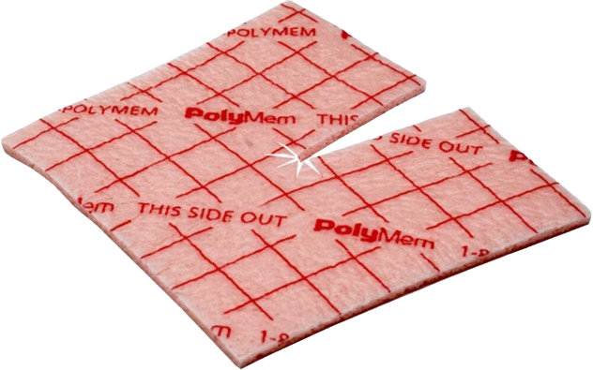 | Dressing Hydropolymer 8x20cm Tielle Lite
 | Product Description
 | Four Functions Polymeric Membrane Waterproof Film Adhesive Sterile Thick Dressing for Highly Exudate Wounds, Flexible Polyurethane Foam Helps in Providing Comfort Contact with Wound Bed Contains F-68 as Specialized Non-Ionic Surfactant Wound Cleanser for Autolytic Debridement, Glycerine for Ideal Moisture Level and Starch Co-Polymer for Managing Exudate Level of Wound. This Dressing Works on Improving the Healing of Wounds and Reducing the Pain Level of Patient.

Client line | 1 | Client reference | 10445
Unit | Each | Item reference | 5335
Cost/each | 15 | Dimensions | 9x9 Cms
Quantity | 10,00 | Country of origin | USA
Vat | 0% | Manufacturer | Ferris mfg. Corp.
MDMA no | Ghtf-1879426875 | Packaging | 15 per box, 2 boxes per case
Shelf life | 5 years | Total line value | Sar15,000
Written total line value |  | Fifteen Thousand Saudi Riyals only

NOTES: *From Sales Order Date
Account Manager: Mohammed Sedky
Contact Info: +966569228091

*From Receipt Date




